CSCI 5010 – Fundamentals of Data Communications

Lab

Static and Dynamic Routing

University of Colorado Boulder

Department of Computer Science

Network Engineering

Professor Levi Perigo, Ph.D.

# Summary

This lab is intended to be an overview of Cisco IOS configuration, and routing technologies, such as static routes, default routes, link failover, and dynamic routing protocols.

The questions in the lab are intentionally vague. The purpose of this is for you not only to research, investigate, and learn the technologies, but also become proficient at interpreting both non-technical and technical questions. Being able to research and discover answers on your own will be critical as you progress in your career.

* Learn how to perform basic router configuration & troubleshooting including:
  + Configure static routes and populate the routing tables
  + Apply administrative distance for automatic route failover
  + Designing and configuring a routing protocol to create dynamically learned routes
  + Routing protocol convergence and failover

# Part 1

# Objective 1: Network Design and Setup [16 points] Create the following network topology, enable all the appropriate ports, and configure the basic setup for the devices in the topology.

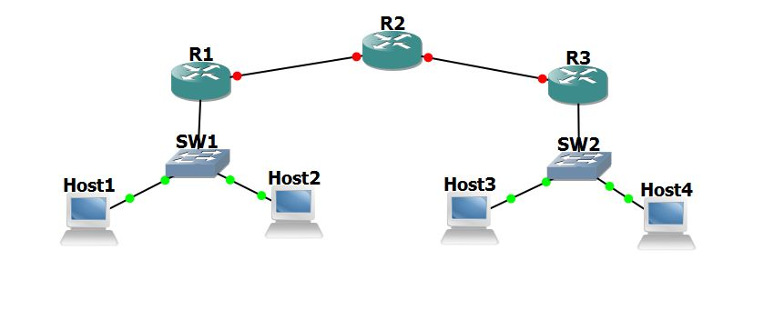

1. Use /24 subnets for all LANs (Each host is in a different subnet) (private IPv4 addresses). Other than IP and subnet, nothing else is configured on the hosts.
2. Use /30 subnets for network connecting routers (private IPv4 addresses)
3. Add your addressing scheme to the network diagram (drawing) indicating the subnets for each network, as well as the interface/PC addresses used in your design [**10 points**]
4. Make sure there is IP connectivity from each PC to the local router (ping the LAN & WAN interfaces).
5. Can PC1 ping the WAN interface IP address of R1? Why or why not? [**2 points**]
6. Is PC1 able to ping R3? Why or why not? [**2 points**]
7. Explain one reason why PC1 could ping the LAN IP address of R1, but could not ping the WAN IP address of R1. [**2 points**]

# Objective 2: Static Routing [14 points]

1. Configure static routes in each router to ensure connectivity between all routers and PCs in the network.
   1. Show the static routes configured
      1. Show the routes in the route table of R1 and R2 [**2 points**]
      2. Show the routes in the running configuration of R3 [**2 points**]
2. Configure Inter-VLAN routing, ensure and maintain 100% connectivity between all devices in the network.
   1. Provide the output from traceroutes from PC1 to PC2, 3, & 4 [**10 points**]

# Objective 3: Dynamic Routing (RIP or OSPF) [30 points]

Create the following network topology, enable all the appropriate ports, and configure the basic setup for the devices in the topology.

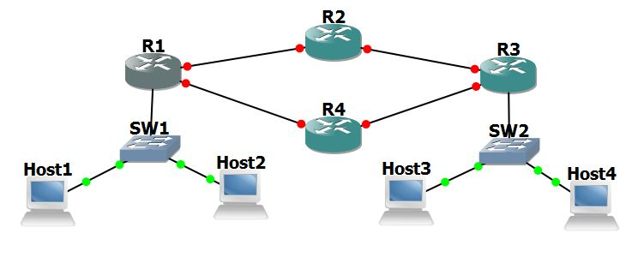

1. Remove the static routes from all router configurations.
2. Configure RIPv2 or OSPF on all router interfaces and networks.
   1. Provide commands used to implement, screenshot of the route table (from R2 & R4) indicating the network has converged [**20 points**]
      1. What does convergence mean, and why is it important? [**10 points**]

Extra Credit: Implement RIPv2 as well as OSPF separately on the network and answer question for Objective 4. **[+5 points]**

# Objective 4: Routing Protocol Failover [17 points]

1. Demonstrate Failover
   1. Issue a traceroute from PC1 to PC3. Which path is it taking? [**2 points**]
   2. Issue a continuous ping from PC1 to PC3.
   3. Remove the router link/connection between the active path routers (discovered in above [1.a]). *For example, if the path was R1, R2, R3, then remove the connection to R2*. 
      1. Were any packets lost? If packets were lost, how long was the network down? Explain this, and indicate how the traffic failed over and the new traffic flow [**5 points**]
   4. Do some critical thinking and research. Could failover be achieved with this network design using only static routes? Explain [**10 points**]

**Report Questions**: [18 points]

* What are the advantages of using routing protocols?
* What is the difference between Distance Vector and Link State Routing protocols?
* What are the advantages of using static routing or when would static routing be preferred over dynamic routing?
* Classify the below routing protocols as Distance Vector and Link State Routing protocols:

1. OSPF, BGP, RIP, IS-IS

* Give:
* Scenario when distance vector routing protocol would be used in the network.
* Scenario when link state routing protocol would be used in the network.
* What is an Administrative Distance (AD) for a routing protocol? Give AD for OSPF and RIP.
* What is a metric in a routing protocol?

# **Extra Credit Q1 - Understanding Routing Protocol [ 25 points ]**

E1.1 For the network given below in Figure. 1, give global distance-vector tables **WHEN:**

1. Each node knows only the distance of its immediate neighbors. **[4pt]**
2. Each node has reported the information it had in the preceding step to its immediate neighbors. **[4pt]**
3. Repeat step (b) one more time. **[4pt]**

5

8

4

2

2

2

4

Figure. 1

Refer the slides below for an example of how to do this question:



<https://www.youtube.com/watch?v=dmS1t2twFrI>

**E1.2 (7 points)**

Again for the network graph in Figure. 1. Show how the link-state algorithm builds the routing table for node D.

1. Show the detailed link-state algorithm. **[5pt]**
2. Show the final routing table of node D. **[2pt]**

Refer the slides below for an example of how to do this question:



**E1.3 (6 points)**

Consider this directional graph below in Figure 4. Use Dijkstra’s algorithm to find the shortest path from node v3 to v5. Write down the **steps**. Do you have any comments on the result (what if the link cost of v3-v1 was 1 instead of 5?)? [**6 pts]**

5

2

3

5

-2

3

2

5

6

Figure. 4

**Extra Credit Q2 [10 points]:**

Consider the above network. RIP and OSPF both are simultaneously working on this network.

For H1 to reach H3, R1 gives a RIP path R1-R2-R3 and OSPF gives R1-R4-R5-R3. Which path would packets from H1 going to H3 via R1 take?

Explain why you think a particular path would be chosen.

# Total Score = ________________/135 (including 40 extra points)